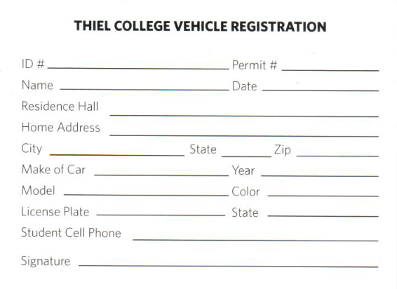
Parking Fines:
Roth Hall $100.00
Handicap space $150.00
Greenville Hall $50.00
HMSC $50.00
Fire lane $50.00
All others $25.00

*All students and employees must have a current parking permit displayed in their vehicle while parked on campus.

*All residential students are permitted to park in white lined parking spaces outside their campus housing and/or in the Passavant Center lot.

*Commuter students with permit numbers C001-C080 are permitted to park in white lined spaces at the gym parking lot or the Passavant Center lot.

*Commuter students with permit numbers C081-C400 are permitted to park in white lined spaces in the Passavant Center lot.

*Parking lots at Roth Hall and Greenville Hall are reserved for employees and guest parking. Students are not permitted to park in these lots at any time.

*The Gym lot is open to residential students after 4:00 p.m. All other lots (except Roth Hall lot and Greenville Hall lot) are open to any students after 5:00 p.m. Vehicles must be moved by 6:00 a.m. the following morning on Mondays through Fridays.

- Yellow Lined spaces in any lot are for employees only
- Students are to park in White Lined spaces only.

Your signature below verifies that you have read and understand the parking rules listed above.

________________________ ____________________
Signature Date
________________________
Print name

