Registering for Traditional Courses

The following information is taken from the PowerCAMPUS Self-Service Faculty Guide.pdf.
We have enhanced it with screen shots.

You can register for traditional courses within a specified academic period access Self-Service at the bottom of the Thiel College webpage (www.thiel.edu).

Password: 9-digit student ID #
123456789
Username: 9-digit student ID # ! (unless changed)
123456789!

1. Select the Register tab (green arrow).
2. Select the Traditional Courses menu item (red circle).

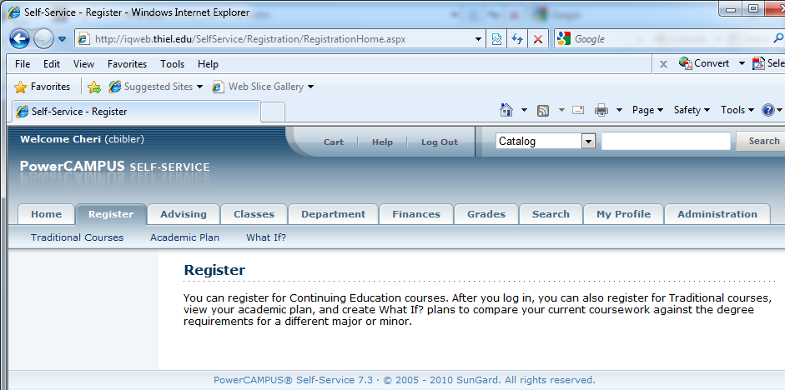

3. Under the Select Period for which you want to register (red circle).
• If the status for the period is OK to register (green circle), select the Period and continue with the registration process.

• If the status for the period is NOT OK to register, you are not authorized to register for this Period at this time. You can contact your advisor for more information (green circle).

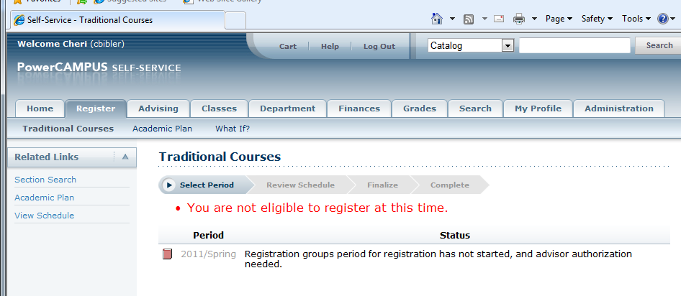

Finding Your Course Sections

- Select Section Search (green arrow).

- Enter your search criteria, and Search for the course sections you want to take.

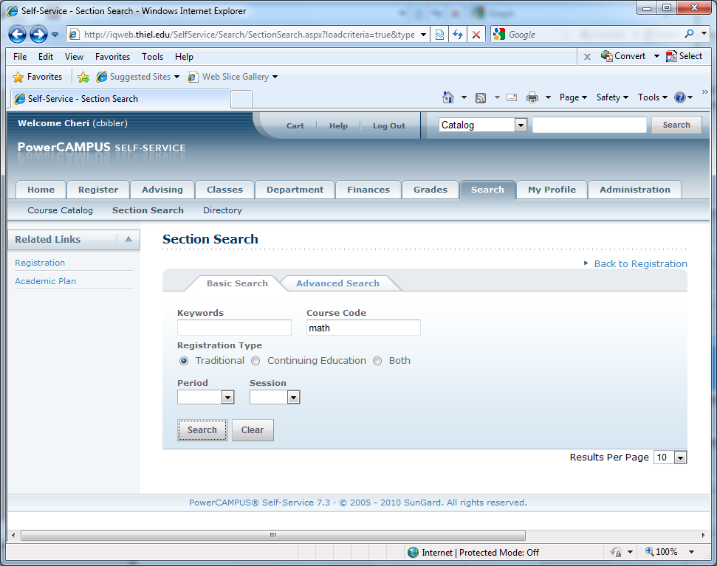

3. View the list of course sections that match your criteria. If too many course sections are listed:
• Select Refine Search
OR
- Choose a specific Period, Session, Department, and so on from the dropdown lists at the top of the Section Search Results page.

4. Open course sections will show. Click Add next to the class you’d like to take.
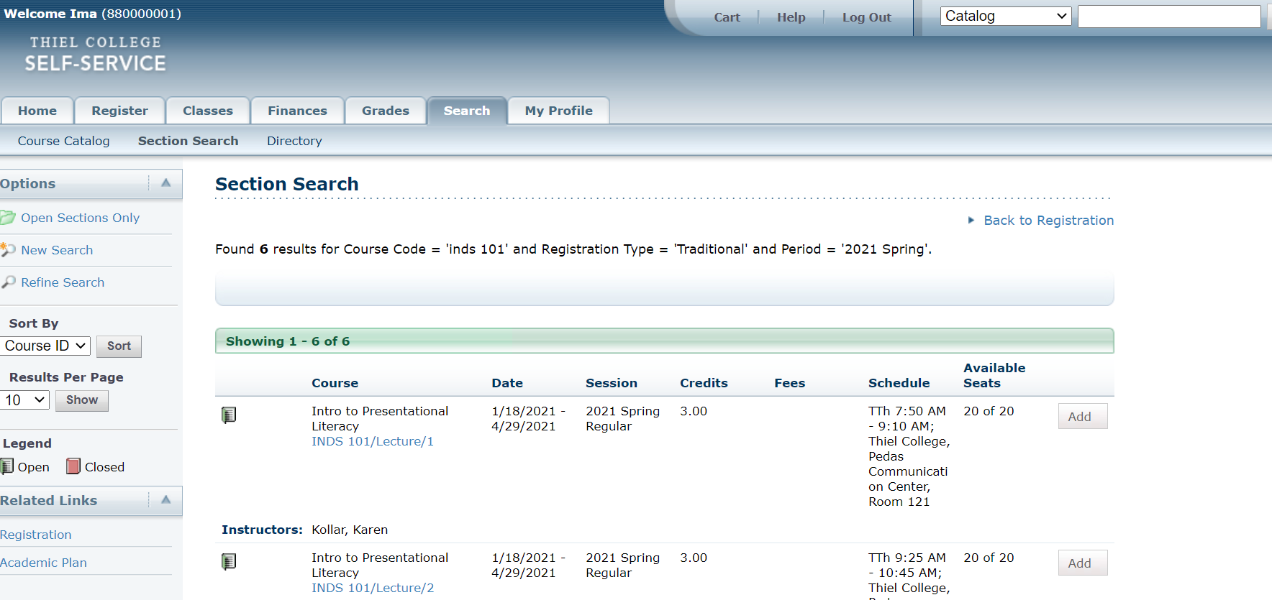

5. Review the Course Added confirmation message that appears above the list of Course Section Results.

.
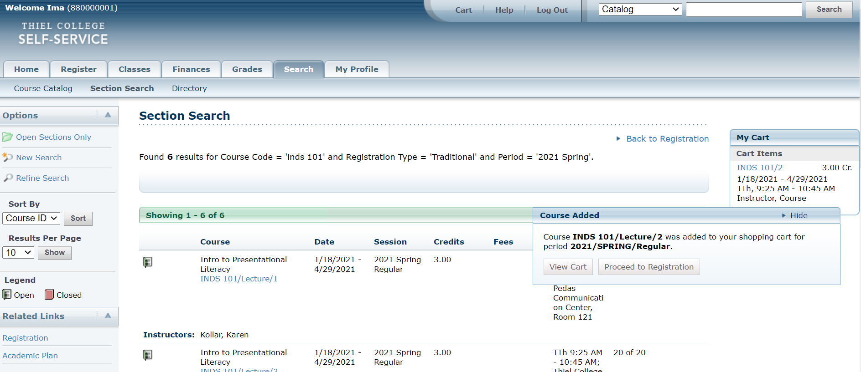
Select To:
- View Cart: Display the current list of courses in your cart (red circle above).
- Proceed to Registration: Continue to add classes (green circle above).
- Request Permission: If you must ask the instructor for permission to take the course, Request Permission
also appears for the course. You can request permission now or when you are viewing your cart.
1. Select Request Permission.
2. On the Request Permission window, view the list of prerequisites for the course.
3. In the Comments field, specify why you want to take this course.
4. Select Send Request to send your request to the instructor.

Verifying the List of Courses in Your Cart

- After you add a course to your cart, you can choose to View Cart (red circle above).

2. As necessary, update the list of courses in your cart. Press the remove button (pink circle below) to remove classes from cart.

- Select View Schedule to see how your schedule looks with the course sections that are in your cart (green) and those for which you are already registered (blue).

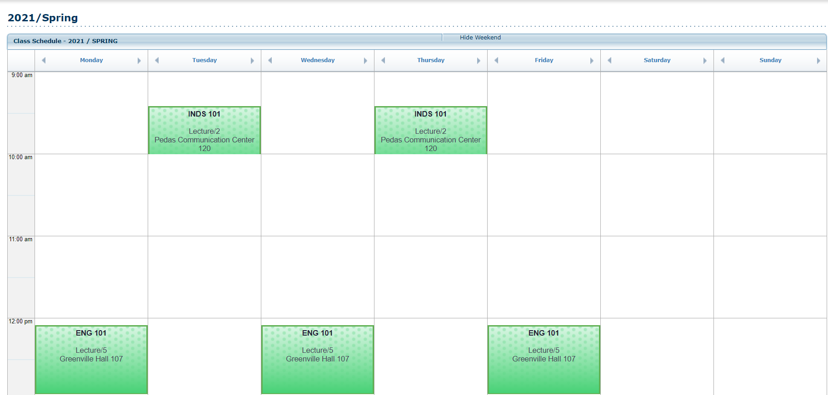

- When you are ready to register for the courses in your cart for an open registration period, select Registration
(or Register on the Cart page).

Registering for the Courses in Your Cart

1. Select Registration (or Register on the Cart page).

2. Review your Schedule to verify the course number, duration, session, number of credits, credit type, schedule, location, instructor, and status for each course.

3. If the course list is correct, select Next (red arrow below).

If there is a conflict in the schedule, you will get a warning. If you get a warning, remove the conflicting classes and go back to Section Search.

- If successful, you will see “Finalize” tab (yellow circle) highlighted, review the list of courses and the
current Status for each course. Click on NEXT (green circle) to proceed.
.

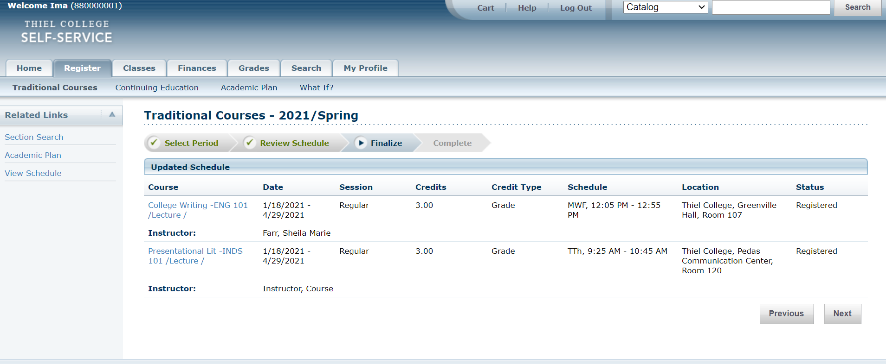

6. Registration is complete! Click View Schedule

7. The schedule can be viewed/printed in 2 formats. TEXT or GRID. Proceed to print by going to tool bar FILE…PRINT.NOTE: check on Wait listed classes if you want them to print then press SUBMIT.

8. To Drop a class after registered, go back repeat steps 3-5 to Review Schedule. Check the Drop box and press Next.

