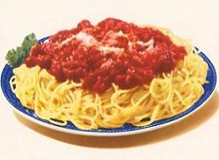
Please Join us for a Spaghetti Dinner/Basket Raffle Benefitting

Dillon Groover

Sunday, April 14th, 2019
12:00 p.m. – 4:00 p.m.

Knights of Columbus
170 Clarksville Street
Greenville, PA 16125

Adults - $10.00 Featuring:
Children under 12 - $5.00 Basket Raffle and 50/50
Take out Available! ½ Pig Cut and Wrapped

Dillon was diagnosed with a brain tumor and had surgery on March 8th, 2019. He has been in Neurosurgical ICU since then. The benefit will help with costs of food, gas, and lodging for his parents as well as any medical expenses.

